**Connect firestore database by using pycharm**

1. We need firebase credentials JSON File , for that we have to go firebase

<https://firebase.google.com/>

check below screenshot for reference

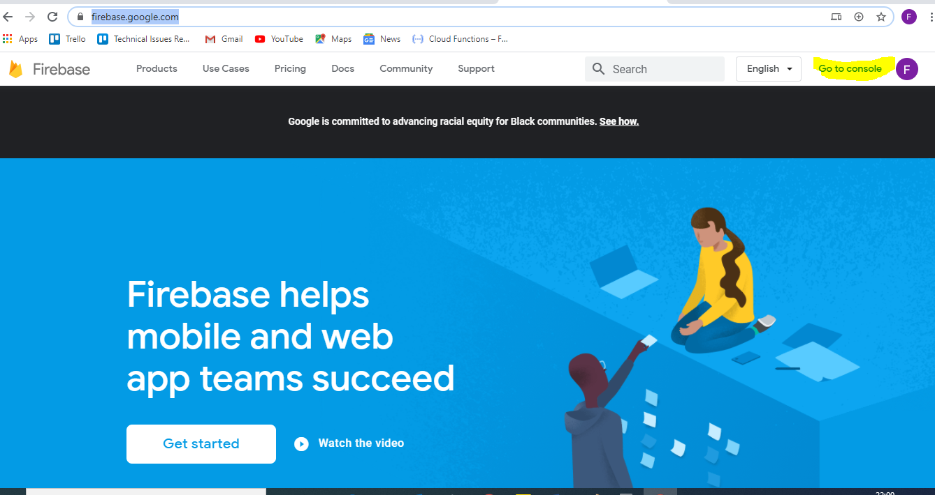

1. Click on console , after that click on FOLK database, check below screen shot

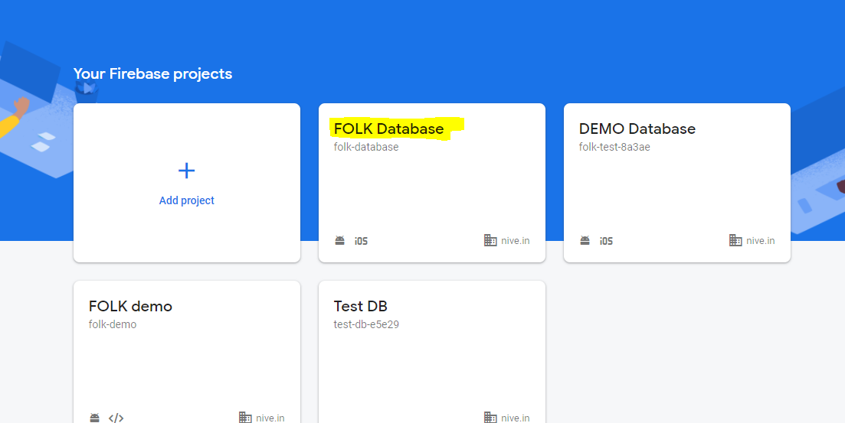

1. Once you click on FOLK database , click on highlighted part in below screen shot

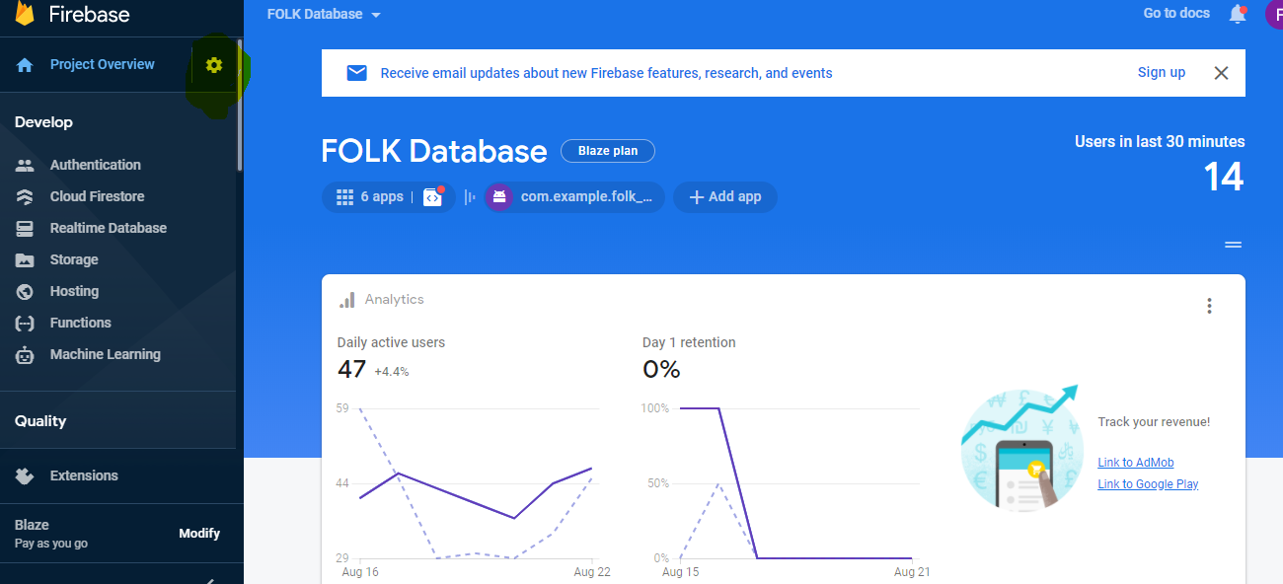

1. After that click on “Service accounts”, check below screen shot and the click on “generate new private key”

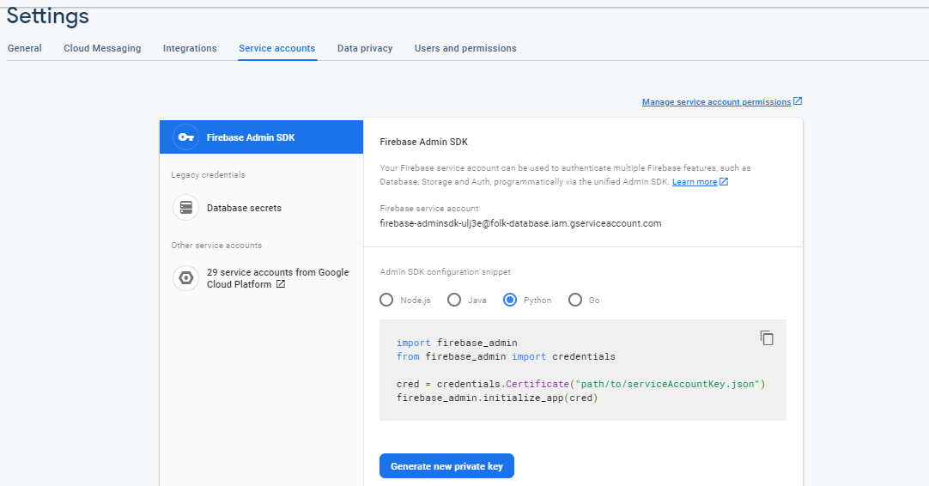

1. Immediately one file downloaded in your system (XXXXXXXXX.json) just copy that file in py charm as it is without changing name

Eg:

That json file I kept has “temp.json”

1. For every firebase program first lines are fixed , if these lines are executing properly then connection establishment with firebase is success, below is the fixed lines of code for your reference (please chage the json file name with your downloaded json file)

|  |
| --- |
|  |
|  | import re |
|  | import firebase_admin |
|  | import json |
|  | import flask |
|  | import requests |
|  | from datetime import datetime |
|  | import time |
|  | from firebase_admin import credentials |
|  | from firebase_admin import firestore |
|  | from firebase_admin import db |
|  |  |
|  |  |
|  | # cred = credentials.Certificate('**folk-test-8a3ae-firebase-adminsdk-l4cmh-4d35e34bd3.json**') “please change which you downloaded just now” |
|  | # |
|  | # firebase_admin.initialize_app(cred, { |
|  | # 'databaseURL': 'https://folk-test-8a3ae.firebaseio.com/' |
|  | # })  db = firestore.client()   1. If the above lines are successfully executed properly means connection establishment with firebase is successful |